The following page provides a general overview of the inventory app's welcome screen. Based on the revised plan from Project 1, the first screen will show the user's current inventory. The page's main content is the item list, which includes the item's description, number, and current count. A clickable link to the item's Detail page may be found in its Description. To make adjustments of one item, use the plus and minus buttons on each side of the Item Count. The user may navigate the list by scrolling up and down. Two buttons may be seen in the body's bottom left corner. By clicking the View tab (the icon that looks like an eye), the user may choose to display or hide certain columns. You may narrow your search by category or value range with the help of the Filter button. By touching the column headings, you may arrange the visible list in alphabetical or numerical order. There is a search box at the top of the page; using it will search all item data for a match to the input, and then display the results in a table formatted similarly to the Inventory page on the Search Page. Last but not least, the dashboard will always be located in the page footer. The buttons will take you directly to the Add Item page, your account information, the main inventory page, the export page, and the support desk. The Export option will populate the currently shown data for printing or sharing.

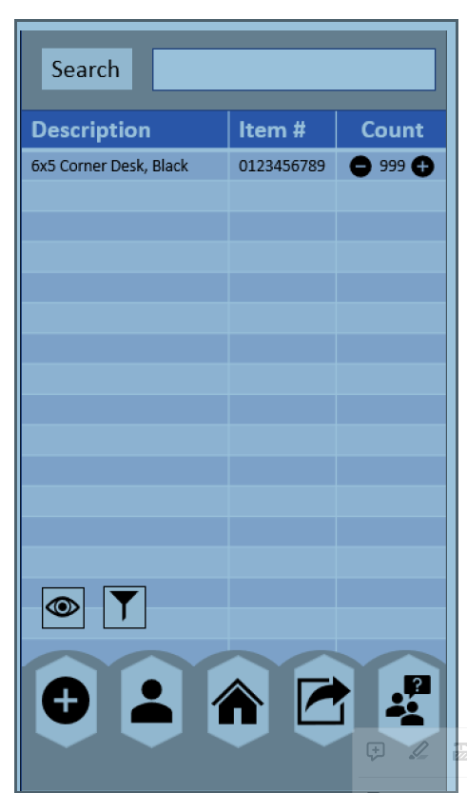

The layout is meant to be intuitive, with easily digestible information shown and easily accessible features. This style does that, and it also provides supplementary capabilities for sorting data as required per user need.